Geometry: Unit 12, Lesson 5
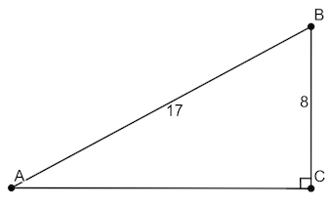
- Triangle $ABC$ is shown, where $m∠BCA=90°$, $AB=17$ units, and $BC=8$ units. What is the length of $\overline{AC}$?

$$AC=15 units$$

- An equation is shown $x^{2}+7^{2}={(x + 1)}^{2}$. What is the value of $x$?

$$x=24$$

- An equation is shown $x^{2}+8^{2}={(x + 4)}^{2}$. What is the value of $x$?

$$x=6$$

